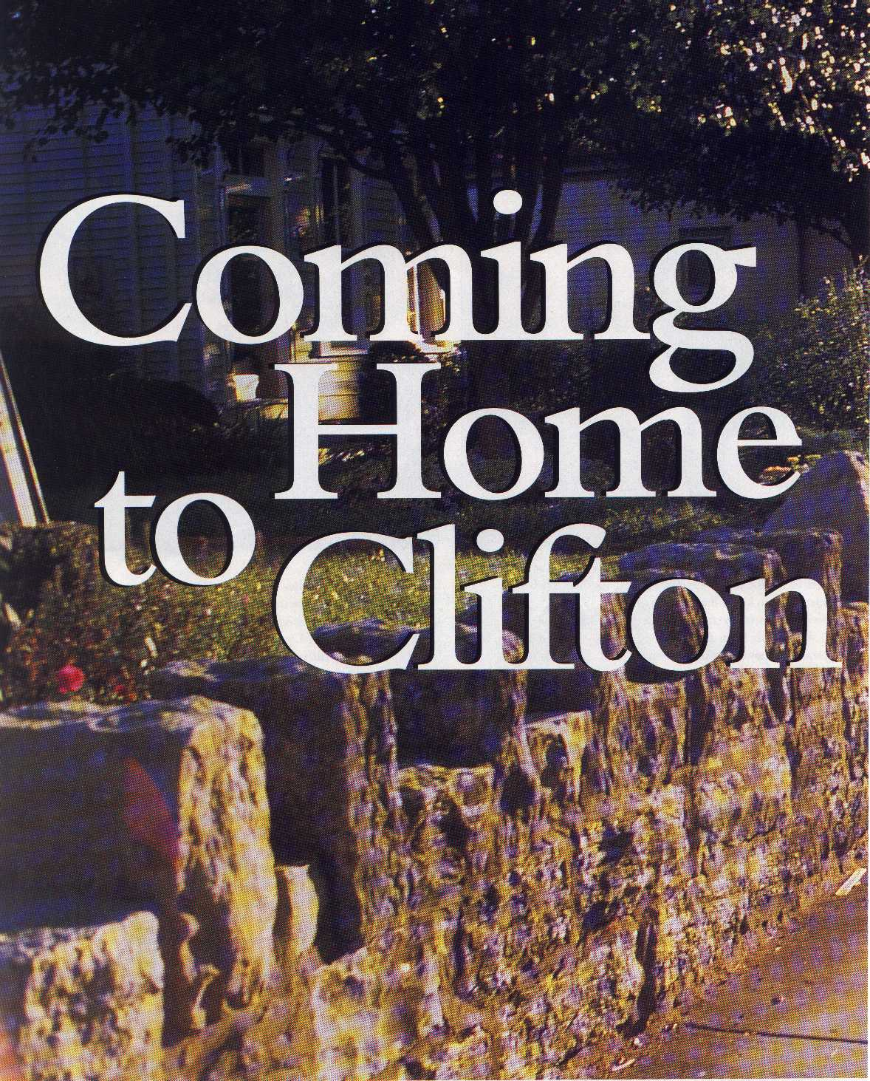
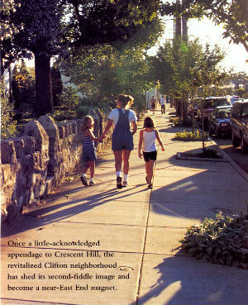

Louisville Magazine September 1999

Your Neighborhood Guide

Clifton Community Council
www.cliftonlouky.org
9/21/2020

Dear New Clifton Neighbor,

Welcome! We’re glad you made a decision to live in historic Clifton, where culture and entertainment meet old-fashioned neighborhood charm. We’ve been a community for over 125 years, and we’re glad you’re part of our growth!

We’d like to invite you to become a member of the Clifton Community Council, a group of residents and businesses dedicated to preserving the past and planning the future. We’re a non-profit council that is devoted to making the neighborhood we all love even better — by preserving our history, helping to balance the needs of businesses and residences, and beautifying our streets, parks, and buildings. Most importantly, we look out for neighbors like you at government functions and meetings. We help your voice be heard!

Look for upcoming newsletters from the Council. In them, you’ll find local interest articles, event announcements, and more!

You can also find out more about Clifton current events and its rich history at our new website – www.cliftonlouky.org

Lastly, we look forward to seeing you at these recurring/upcoming events:
- Clifton Community Council Board of Directors Meeting (monthly & open to the public)
- Clifton Community Council Quarterly General Meeting (quarterly & open to the public)

Wishing you all the best in your new home,
The Board of Directors
Officers:
President, Mike O’Leary, michael.oleary@twc.com
Vice-President, Brad Curry, brad@kypropertyguy.com
Secretary
Treasurer, Pam Vetter, pamavetter@gmail.com
At-Large Members:
Joey Keck, jokeck5@gmail.com
Bill Wright, bww0912@gmail.com
Bill Lieshoff, blieshoff@gmail.com
Tom McIntyre, r.thomas.mcintyre@gmail.com
Matthew Glaser, matthew.glaser@yahoo.com
John Spetz, jspetz@twc.com
Zach Leonardo, pzleon01@gmail.com

Join the Clifton Community Council!

Annual dues are just $10.00 per year

(per adult resident or business entity)

Your membership and volunteerism make a difference. As a 501(c)(3) non-profit organization, we rely on neighbors like you to help Clifton continue its positive development.

If you have questions or comments, you can contact any of the Council Board-of-Directors.

Please fill out this form and mail to:

Clifton Community Council
123 Waverly Ct #1
Louisville, KY 40206-2040

Cash or personal checks are accepted.

Make checks payable to “Clifton Community Council.”

or pay on-line at www.cliftonlouky.org

NAME: ________________________________________________________________

ADDRESS: _____________________________________________________________

CITY, STATE: ________________________________________ ZIP: _______________

TELEPHONE: ___________________________________________________________

EMAIL: ________________________________________________________________

( ) Yes! I would like to become a member of the Council. My check is enclosed.
( ) Yes! I would like to make a donation to the Council. My check is enclosed.
( ) Yes! I would like to volunteer with the Council! I am interested in (check any that apply):
___ Beautification (planting, weeding, watering, clean-up, and more)
___ Land Use and Preservation (zoning, historical and architectural projects)
___ Membership
___ Newsletter (article writer, advertising, editor, and carriers)
___ Pedestrian and Bike Access concerns
___ Special Events (fundraisers, festivals, holiday events, etc.)
___ Other: _________________________________

3

Neighborhood Notes

Answers to Common Questions About
Clifton

Garbage/Recycling – Junk Days

Police, Fire & Emergency Services

Voting Districts – Elected Officials

Schools – Churches

Parks - Library

Walking – Biking

And More!

www.cliftonlouky.org

The Clifton Community Council has made every effort to include complete information under each topic. However, some information may be missing, outdated, or incomplete. If you notice any information or organization names that are missing from this guide, please let us know.

5

Boundaries
Clifton covers 2,000 structures on 423 acres, from Brownsboro Road to the north, I-64 to the south, Ewing Avenue to the east, and Mellwood Avenue to the west.

History
Clifton was officially annexed by Louisville in 1891, though portions of it were developed long before. The earliest structure known to exist in Clifton was built around 1820. The oldest structure that is still standing (2311 Frankfort Ave, formerly the Tollhouse) was built in 1830.

Demographics
As of 2002, 79.5% of Clifton was zoned residential, 10.9% was zoned commercial, and 9.6% was zoned industrial.

Garbage/Recycling Day
Waste is collected on Tuesday (garbage only) and Friday (yard waste and recycling). Yard waste may be set out in garbage cans or paper bags as long as each can or bag weighs no more than 60 pounds and can be easily lifted by the average person. All yard waste must be set out by 6:00 a.m. on collection day and no earlier than 4:00 p.m. on the day before collection day. All containers must be removed from the street or alley no later than 4:00 p.m. the day after collection and stored on the property.
Curbside garbage cans should be placed on the grassy strip between the sidewalk and street. If there is no grassy strip, the best alternatives are to place the garbage can in the street or on the grass, but not on the sidewalk. This also applies to the orange recycling and yard waste containers.
No household garbage can be mixed with grass, leaves, or other yard waste. Woody waste (such as tree limbs and shrub trimmings) should be less than 2 inches in diameter and should be cut into 4-foot lengths and securely tied into light bundles.

Junk Day – Street Sweeping
Junk is collected 3 times a year (March, June, October). The pick-up dates vary each year, and appear on a Metro brochure mailed annually to all Clifton households. If you missed this brochure, simply phone MetroCall at 311 or 574-5000, or refer to the web page at: https://louisvilleky.gov/government/public-works/solid-waste-management-services.
Street sweeping occurs in the spring and in the fall , check on-line at: https://louisvilleky.gov, scroll to the bottom of the page to ‘My Louisville’ and enter your address to check for dates. .

Replace a Damaged Garbage or Recycling Cart
Let Metro Solid Waste know if you have a damaged cart. They will repair or replace it for free once a year if damage is shown. Call MetroCall at 574-5000 and provide them with your name, address, and daytime phone number along with the serial number from the cart and a description of the damage. Or go on-line at - https://forms.louisvilleky.gov/Curbside-Services.aspx
6
Police District
Clifton is in Louisville Metro Police Department’s 5th Division, Beat #1. This division reports to Major Aubrey Gregory, 2301 Douglass Blvd., Louisville, KY 40205,502-574-7636. Remember to always dial “911” for emergency service. The non-emergency number is 502-574-7111. Find out more at: http://www.louisville-police.org/173/Fifth-Division.
LMPD 5th Division Email. 5thdivlmpd@louisvilleky.gov This is an email address that is monitored by the 5th Division Command Staff and District Resource Officers. If you would like to contact them, sign up to receive weekly crime reports, or tell them about issues in the neighborhood this is a great way to connect.

Fire District
Clifton is included in Fire Districts 2 and 4.
District 2 (Telesquirt 21), 300 N Spring St., 502-583-5678 or 502-589-3910
District 4 (Engine 4), 2620 Frankfort Ave., 502-896-9291
Remember to always dial “911” for emergency service.

Political Districts and Elected Officials
Clifton’s 2008 districts and corresponding representatives are as follows:
- Council Member District 9: Bill Hollander, 502-574-1109
- U.S. Congressional District 3: John Yarmuth, 502-582-5129
- Kentucky Senatorial District 19: Morgan McGarvey, 502-564-2470
- Kentucky Senatorial District 33: Gerald A. Neal, 502-564-8100 x 655
- Kentucky Legislative District 42: Reginald Meeks, 502-564-8100 x 653
- School Board District 2: Chris Kolb

Voting Districts
Your voting district depends on where you live in Clifton. The three voting districts in Clifton include M141 (northern/western sections of Clifton), M142 (central sections of Clifton), M143 (southern/eastern sections of Clifton). If you have questions about your voting district, call the Board of Elections at 502-574-6100 or go to: http://jeffersoncountyclerk.org/wheredoivote/. The voting sites are either: United Crescent Hill Ministries, 150 State St. or Barrett Middle School, 2561 Grinstead Dr.

Metro Government Service Inquiries
Want to report a pothole? Find out about a waterfront concert? Report graffiti? Metro311 offers a fast, simple, and convenient way to obtain information or request a service from Louisville Metro Government. You can reach them:
- By calling 311 or 502-574-5000 (Monday-Friday, 7 am to 7 pm.)
- Emailing - metro.call@louisvilleky.gov
- Visiting - https://louisvilleky.gov/government/metrocall-311
- Twitter - @LouMetro311 Or with the Metro311 app

7
Preservation District violations

Call Metro311 by simply dialing “311” or tweet @LouMetro311. Report the address and what you saw — and be sure to mention you live in the Clifton Preservation District. Also, mention you want the complaint delivered to the “Landmarks Commission.” Some exterior modifications include: additions, doors, garages, porches, roofs, siding and trim, windows, fences, and retaining walls.

When Do You Need A Permit?
Did you know you need permits for construction, alteration and the change of exits on a house. Permits are needed for installing new electrical service or adding fixtures, such as ceiling fans, replacing water service, moving a sink or toilet, installing central air, widening a driveway and tearing down a residence or outbuilding. Before you widen, install, add or remove, check to see if you need a permit so the work you do meets code standards.
Metro Construction Review issues permits for all building construction, alterations or wrecking. Whenever plumbing, electrical, wiring, heating or structure of a building is going to be changed or a new structure built, the contractor or owner doing the work needs a permit. The completed project must be inspected to be sure it meets code guidelines. Call 574-3321, or on-line at: https://louisvilleky.gov/government/construction-review

Sidewalks and Right of Ways
The property owner is responsible for the upkeep of sidewalks and alleys. This includes keeping trees, bushes, and debris from blocking sidewalks; and snow removal. If in need of repair, funds from Metro Council may be available. Funding is limited, but not reporting it will mean that it will never be considered for repair. To participate in the sidewalk repair program for the sidewalk in front of your house and get on the list, call the Metro Council District 9 office at 502-574-1109 or email Kyle at kyle.ethridge@louisvilleky.gov and include the exact address.
It is illegal to park any vehicle on a sidewalk, crosswalk, or the grassy area between the sidewalk and street; or within 4 feet of a driveway, or within 8 feet of a fire hydrant.
It is illegal for anyone 11 years and older to ride a bicycle on a sidewalk.
It is also illegal for utility company or service vehicles to park on a sidewalk or crosswalk. If a parked car is causing an unsafe situation needing immediate attention, call the Police non-emergency number at 574-7111 or call the Fifth District at 574-7636.

Utility Companies
There are many telecommunications, cable, and Internet providers serving the Louisville area. The “ground service” utility companies are listed below, along with their information:
Louisville Gas & Electric (LG&E) Louisville Water Company
220 W. Main Street 550 S. Third Street
Louisville, KY 40202 Louisville, KY 40202
(502) 589-1444 (502) 583-6610
www.lge-ku.com www.louisvillewater.com

8
Public Parks and Pool
Clifton is lucky to have three parks within its boundaries: Arlington Park, Bingham Park, and Found Park. All are open from dawn to dusk.
Bingham Park is located off Brownsboro Road, in the wooded ravine between Haldeman Avenue and Coral Avenue. At four acres, it is Clifton’s largest (and oldest) park. It was designed by the Olmsted Brothers’ landscaping firm in 1913 and now constitutes four acres, including paths, a basketball court, picnic tables, a playground, public restrooms, and a spray pool. The large grassy areas and wooded perimeter make it a great place to walk your dog, too (please clean up after them!).
Clifton Park is a one-acre park that was acquired in 1976. It is located at the corner of Arlington Avenue and Charlton Street, between Stevenson and I-64. Amenities include basketball court, grills, picnic tables, a playground, and a tennis court. There is also an ample grassy area for walking your pets or picnicking.
Found Park is conveniently located behind North End Café, between Frankfort Avenue and Stevenson Avenue. Found Park was dedicated in 2005 as a “rest stop” for bikers and walkers. Amenities include seating and a bike rack. It’s a great spot to read or write!
Mary T. Meagher Aquatic Center, 201 Reservoir Avenue, offers lap swim, water exercise and swim lessons, as well as a weight room with Cybex, free weight and cardio equipment. All pools require a photo ID for anyone age 9 and over (children under the age of 9 years old must be accompanied by a guardian). Swimming classes are provided year around, and lifeguard training February thru June. https://louisvilleky.gov/government/parks/mary-t-meagher-aquatic-center

Library and Museum
American Printing House for the Blind Crescent Hill Library
1839 Frankfort Avenue 2762 Frankfort Avenue
502-895-2405 502-574-1793
www.aph.org www.lfpl.org

Post Office
There is not a post office in Clifton, but there is one at the Masonic Home in Crescent Hill, 3761 Johnson Hall Dr. 502-893-893-7621. Once you’re on the grounds, just follow the signs! You can also purchase stamps at Kroger and CVS.
Collection boxes are located at: Kroger, 2200 Brownsboro Rd., Frankfort & Vernon Ave., and Frankfort & Ewing Ave. by Walgreen’s.

Social Services
United Crescent Hill Ministries, 150 State St., 502-893-0346, www.uchmlouky.org. is the community service agency servicing the residents in zip code 40206. Their programs include: emergency assistance, food pantry, senior services, Meals On Wheels, Visiting Nurse, Recreation and Wellness, youth programs, after-school and summer camp programs.
Metro United Way 211 Helpline will help you find additional local services. Dial 211 or their alternate numbers 502-753-2201 or 877-566-4968. Or text your zip code to 898211 (TXT211).
Or visit their website at: https://metrounitedway.org
Churches
Member churches are listed at www.uchmlouky.org

Beargrass Baptist Church Crescent Hill Baptist Church
2300 Payne Street 2800 Frankfort Avenue
502-893-5653 502-896-4425
www.chbcky.org

Clifton Baptist Church Crescent Hill United Methodist Church
1947 Frankfort Avenue 201 S. Peterson Avenue
502-897-1771 502-896-0396
www.cliftonbaptist.org www.chumchurch.com

Clifton Universalist Unitarian Church St. Mark’s Episcopal Church
2231 Payne Street 2822 Frankfort Avenue
502-895-3189 502-895-2429
www. uu.org www.stmlky.org

St. Frances of Rome Catholic Church Third Lutheran Church
2119 Payne Street in the Chapel of Clifton Baptist
502-896-8401 502-896-6383
www.saintfrancesofrome.org www.thirdlutheranchurch.org

Northeast Christian Church-Clifton Campus Grace Immanuel United Church of Christ
131 Vernon Ave 1612 Story Avenue
502-896-0302 502-587-6190
www.necchurch.org/cliftoncampus www.graceimmanuelucc.org

Schools
There are many public and private educational institutions in and around Clifton. You can learn more about Jefferson County Public Schools at www.jefferson.kyschools.us. Catholic schools at:
www.louisvillecatholicschools.com

Breckinridge-Franklin Elementary Emmet Field Elementary School
1351 Payne Street 120 Sacred Heart Lane
502-485-8215 502-485-8252

Meyzeek Middle School Barrett Traditional Middle School
828 S Jackson Street 2561 Grinstead Drive
502-485-8299 502-485-8207

Atherton High School Waggener Traditional High School
3000 Dundee Road 330 S. Hubbards Lane
502-485-8202 502-485-8340

Kentucky School for the Blind Holy Trinity Clifton Campus (to open 2019)
1867 Frankfort Avenue 2117 Payne Street
502-897-1583 502-896-8480
www.ksb.k12.ky.us www.htcliftoncampus
10

Assisted Living, Skilled Care, Rehabilitation Centers, Etc.
Nazareth Home Clifton Masonic Homes of KY-Louisville
2120 Payne Street 3701 Frankfort Avenue
502-895-9425 502-259-9627
www.sacredheartlou.org www.masonichomesky.com/louisville-2

St. Joseph’s Children’s Home Brownsboro Hills Nursing Center
2823 Frankfort Avenue 2141 Sycamore Ave
502-893-0241 502-895-5417
www.sjkids.org

TARC Bus Routes
TARC (the Transit Authority of River City) is the local system of interconnecting bus routes. You can reach them by calling (502) 585-1234 (automated for 24-hour service) or by visiting www.ridetarc.org. TARC buses can accommodate bikes, wheelchairs, and other mobility devices.
A sample of the routes that serve the Clifton area are included below. Check TARC schedules for details and other bus routes—they are available at any local library.
Bus 19: Muhammad Ali Boulevard
This route connects Shively and Riverport to St. Matthews and beyond to the Dupont area. It can get you to Fourth Street Live in less than 20 minutes and St. Matthews in about 10 minutes.
Bus 15: Market Street
This bus runs from Shawnee Park to Lyndon. It covers all of Frankfort Avenue in Clifton and connects you to downtown in about 15 minutes. It is also good for getting to Veterans and Central State Hospitals, but consult a schedule to make sure you get on the right bus.
Bus 31: Middletown
The Middletown bus covers all of Frankfort Avenue. It goes from Fourth and Broadway all the way east to Middletown and Berrytown. The route can take you to most sections of the downtown business district and to the malls in St. Matthews. Check the schedule because this is an express during rush hours, and embarking and debarking times are limited in Clifton.
Bus 25: Oak Street
This route follows Grinstead Drive through the Highlands neighborhood and into Old Louisville. It runs about every 30 minutes during most of the day, on weekdays. It can get you to the Rudyard Kipling, Central Park, St. James Court, and the Old Louisville historic districts.
As of summer, 2018, “10 Ride Tickets” are 10 for $15.00, and are available at any Fifth Third Bank including the branch inside Kroger at 2200 Brownsboro Road. Monthly Passes – and several lower-fare options for seniors, students, and citizens with disabilities are also available. You can also purchase tickets on-line at www.ridetarc.org.

11
Walking and Biking
Clifton is a neighborhood that is ideal for both walking and biking. From quiet, tree-lined streets to the bustling variety of Frankfort Avenue, the Clifton neighborhood is a wonderful place to experience outdoors.
Walking
Fortunately, the many restaurants and businesses in Clifton mean much of life’s necessities are nearby. Walking to a grocery, coffee shop, café, church, library, barbershop, or public park is easy and enjoyable.
Because Clifton is home to one of the largest communities of visually impaired people in the country, the traffic lights in Clifton have audible signals which benefit all pedestrians.
The “Chicken Steps,” a pedestrian pathway that connects with railings from the north end of Vernon Avenue to Brownsboro Road below (named for the chickens that used to roost there), can make navigating the steep cliff overlooking Brownsboro Road easier.
Bicycling
Bicycling through the Clifton neighborhood is a wonderful experience. Biking provides the sensory experience of walking but with the speed and distance required for many of our daily errands. A warm summer night spent coasting down Payne Street with the constant breeze in your face and the scent of honeysuckle in bloom is an experience to remember.
The bustling activity on Frankfort Avenue and Brownsboro Road may attract you when you walk, but they may not be the best bike routes. Remember, a current Metro Louisville ordinance prohibits adults from riding bikes on sidewalks.
Because of traffic on Frankfort Ave., you may want to try the less-traveled Payne Street, which connects with alleys to Ewing and serves as a safer east-west route south of Frankfort Ave.
Another hazard is the railroad tracks crossing Frankfort Ave. These are at an angle and can catch the wheel of your bike. Be sure to cross at right angles to the track, or avoid the crossing altogether by walking your bike across the pedestrian walkway connecting Clifton Ave. from the north side of Frankfort Ave.
Here are a few bike routes you may want to explore:
To Cherokee Park: Ride west on Payne St. over the I-64 bridge, then turn right on Spring Street (or, alternately, at the first alley). Take another right on Locust Ave. and follow it until the street dead-ends. The entrance to the bike path is on the right. This path follows Beargrass Creek to Lexington Rd. at Grinstead Dr. You can then use the crosswalks to walk your bike to Cherokee Park. The park is one of the city’s finest features, and it has a paved loop for bicyclists and pedestrians as well as numerous off-road paths for mountain biking.
To Butchertown Greenway and the River: From the northwest corner of Brownsboro Road and Mellwood Avenue, ride west on Brownsboro to Story Avenue, then turn right. Follow the multi-use path under Interstate 71, the railroad tracks, and River Road to the bank of the Ohio River. From there you can ride west to the Baseball Stadium and downtown, or east to Eva Bandman Park. (Alternately, if you’d like to avoid riding on Mellwood Avenue or Brownsboro Road, take Frankfort Avenue north to William Street, turn north onto William and left on the first alley. This turns north to meet Mellwood Avenue just south of Brownsboro Road. Use the crosswalks to walk your bike to the northwest corner.)
12
To Grocery Shopping: Bicycling to Kroger can be challenging because it is located at the bottom of the “cliff,” but the store does have a bike rack once you get there. It is located under the overhang on the west side of the store. You could also lock up your bike at the top of the Chicken Steps at the north end of Vernon Ave. and walk, or use Clifton Ave., which has direct access to the parking lot. You can also pick up convenience items at Walgreens at Ewing Ave.
Make sure you secure your bike when you leave it. There are bike racks in many places along Frankfort Avenue all the way through Crescent Hill, and at destinations such as the Kroger on Brownsboro Road. You can always improvise by using a railing or pole—just be sure to leave ample room on the sidewalk for pedestrian traffic.

Louisville Metro has designated several bike routes through the city. Green signs reading “Bike Route” indicate these designated routes. The bike route that passes through the Clifton neighborhood is along Payne Street. To see the bike route maps, go to Bike Louisville at https://louisvilleky.gov/government/bike-louisville

2018 Kentucky Bicycle Passing Law
The 2018 Kentucky Legislature passed a three-foot bicycle passing law that took effect July 14, 2018.
The law requires vehicles passing a bicycle to use the adjacent lane if available. If an adjacent lane is not available, then the passing vehicle should pass to the left at a distance not less than three feet between the vehicle and the bicycle. If the bicycle is in a bicycle lane, the passing vehicle should still be at least three feet from the bicycle.
Distance is measured from the outmost portion of the vehicle to the outmost portion of the bicycle. A pickup truck with wide view mirrors would require a space of three feet from the mirrors to the end of the bicycle handlebar.
If the roadway, the distance from the edge of the pavement to the other side of the pavement, is too narrow to give three feet clearance, then the passing vehicle should use reasonable caution. Typically, this will occur on one-lane roads less than 10 to 12 feet wide.
The new law also allows passing vehicles to legally cross a double yellow line to pass a bicycle – if there is enough sight distance to safely pass, considering the slower speed of the bicycle and greater visibility around the bicycle.

Trains – Quiet Zone
On any day, there could be around 30 trains that travel through Clifton at the Frankfort Ave. railroad crossing, operated by CSX Transportation. In 2008, Metro Council approved funds to construct the 6-inch concrete medians, which are needed to comply with new federal safety standards. These improvements retained the Quiet Zone and saved the neighborhood from hearing train horns more than 30 times a day.

13

What Does it Mean to Live in a
Preservation District?

As a Clifton resident, chances are you own or rent a home or business with some age to it. Most homes in Clifton were built between 1870 and 1950. All of the buildings in Clifton are located in the Preservation District, which is a special district that makes sure the neighborhood retains its overall character.
Just because your home is in a Preservation District doesn’t mean you can’t renovate it or make changes to improve its property value. What it does mean is that you should pay special attention to the house before you decide on your renovation plan, and preserve or replicate as much of the original look as possible. And of course, building codes and permit laws exist for any renovation and demolition, regardless of whether you’re in a Preservation District or not.
Practically speaking, living in a Preservation District means:
- You can renovate and make exterior modifications to your home as long as it compatible or replicates the home’s original exterior design, style and character defining features.
- You CANNOT demolish or remove ANY buildings – including old sheds, garages, etc. – without PRIOR APPROVAL. You cannot just demolish an old shed, garage, etc. that looks in bad shape or needs substantial repair. You MUST receive approval FIRST from Metro Landmarks staff (see next item below). We’re bolding this because some new residents have said that this was not clear to them.
- You must apply for a Certificate of Appropriateness for your proposed exterior changes with the Metro Landmarks Commission staff. You must receive approval before you begin construction or alterations. The Metro Landmarks staff can be reached at (502) 574-6230 or by visiting https://louisvilleky.gov/government/planning-design/historic-preservation-landmarks-and-overlay-districts. The web site has all the forms and instruction you’ll need in printable PDF format.
- You should post your approved Certificate of Appropriateness in a visible location on your property once you receive it. Posting your approval ensures that you will not be fined for starting your project without obtaining approval first.
The Clifton Community Council’s Board of Directors wants to make sure you enjoy the charm of our community for years to come. If you have questions about the design review process, please contact us.

14
Applying for a Certificate of Appropriateness
The Application Process
Metro Construction Review will not issue a building or demolition permit affecting a property within a Preservation District without a Certificate of Appropriateness. Property owners should submit an application for exterior modifications to the Landmarks Commission (444 S. 5th St.) along with the following information:
- site plans, photographs, and other graphics to show the proposed exterior alteration in the context of property lines, adjacent structures, streets, sidewalks, etc;
• plans, elevations, and other drawings, and a complete description of the material to be used, as may be necessary to fully explain the exterior alteration; and
• clear photographs of the existing structure or site condition.
Applications for demolition shall also include:
• information establishing that an owner-occupied property cannot be put to a reasonable beneficial use without the approval of the proposed work; or
• information establishing that the applicant cannot obtain a reasonable return from an income-producing property without the approval of the proposed work.

Pre-Application Conference
Before submitting an application, an applicant may request a pre-application conference with the staff to discuss the proposed work and applicable design guidelines.

Activities Excluded From Review
Certain activities are not considered exterior alterations and, therefore, are not subject to review. A brief list provided below outlines these activities. More detail is available in the Code of Ordinances (Chapter 32.506).
• ordinary exterior repairs which exactly reproduce existing design and existing materials;
• installation of house numbers, mail boxes, small porch lights, kick plates, or door knockers;
• interior alterations that do not affect the exterior;
• painting non-masonry materials;
• repainting masonry that is currently painted;
• landscaping, tree trimming, or pruning;
• rear yard improvements not visible from the street and which do not involve alterations to any structures;
• removal of signage without replacement;
• temporary signage removed within six months; and
• emergency repairs ordered by a Metro Code enforcement officer to protect health and safety.

Exterior Alternations Reviewed
Chapter 32.500 et seq. of the Metro Code of Ordinances establishes a review process for any exterior alteration, demolition, or new construction proposed for any property or structure located within a Preservation District. Such projects are evaluated according to the Clifton specific Preservation District Design Guidelines.

15
Review Process
The review process begins once an application is determined to be complete. Staff members classify completed applications as requiring review by staff or an Architectural Review Committee (ARC). Each ARC meets to hear applications on the second and fourth Wednesdays of the month. The volunteer committee members evaluate applications on the basis of the design guidelines. Applicants, as well as abutting property owners, are notified in writing by mail of the hearing date mailed at least seven days in advance. Applicants are encouraged to attend these meetings, since it is an opportunity to discuss the proposed work and provide additional information if required.

Certificate of Appropriateness
Upon review, the staff or ARC will take one of three actions:
• approve the application as it is;
• approve the application with conditions; or
• deny the application.
A Certificate of Appropriateness certifying that the property complies with the design guidelines is issued if an application is approved or approved with conditions.
A majority of the Certificate of Appropriateness applications are approved by staff, the remainder are reviewed by the Clifton Architectural Review Committee. Most applications are approved with conditions. In Clifton for 2019, 77 applications were received. There were 9 ARC meetings with 21 cases being reviewed by the ARC. All but one of the 77 cases were approved with conditions.

16

Preservation Principals to Keep in Mind
These preservation principles are modeled after the Secretary of the Interior’s Standards for Rehabilitation. Reading through these principles will help you begin to think about how you can carry out your upcoming Clifton project in a way that enhances your historic building while preserving its character-defining features.

Relationships
When evaluating the appropriateness of a given project, consider the structure, the site, and their relationship to the rest of the neighborhood.

Use
Historic structures within Clifton should be used for their originally intended purpose or for an alternate purpose that requires minimal alteration to the building and site.

Alterations
Repair is always preferred over replacement. When replacement is necessary, materials should replicate, match or be compatible with the visual appearance of the original. A high level of craftsmanship distinguishes structures within Clifton. Distinctive features, finishes, and construction techniques should be preserved whenever possible. Avoid the removal or alteration of historic fabric that compromises the original character of your building or site. Since properties do change over time, consider those alterations that have become historic in their own right and should be maintained as a record of a resource’s physical evolution.

New Construction and Additions
Additions should be designed to minimize impact to historic fabric and should relate to the main structure in massing, size, and scale. New construction should be designed so that it relates to its neighbors in size, massing, scale, setback, façade organization, and roof form. New construction and additions should also draw upon established or new stylistic elements to create a sympathetic design that is clearly of its own era.

False Historicism
Avoid new or salvaged material that creates a conjectural or falsely historical appearance.

Treatments
Chemical and physical treatments should always be as gentle as possible, since harsh methods like sandblasting can irreversibly damage historic fabric.

Archaeology
Historic sites often contain archaeological resources, which should be protected and preserved whenever possible. If artifacts are found, contact the Metro Landmarks staff (502-574-6230) for an assessment.

17

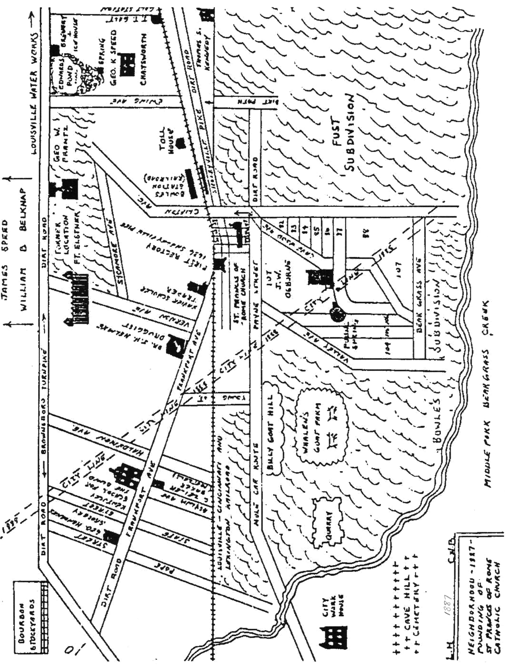

18

Clifton

A Brief Neighborhood History

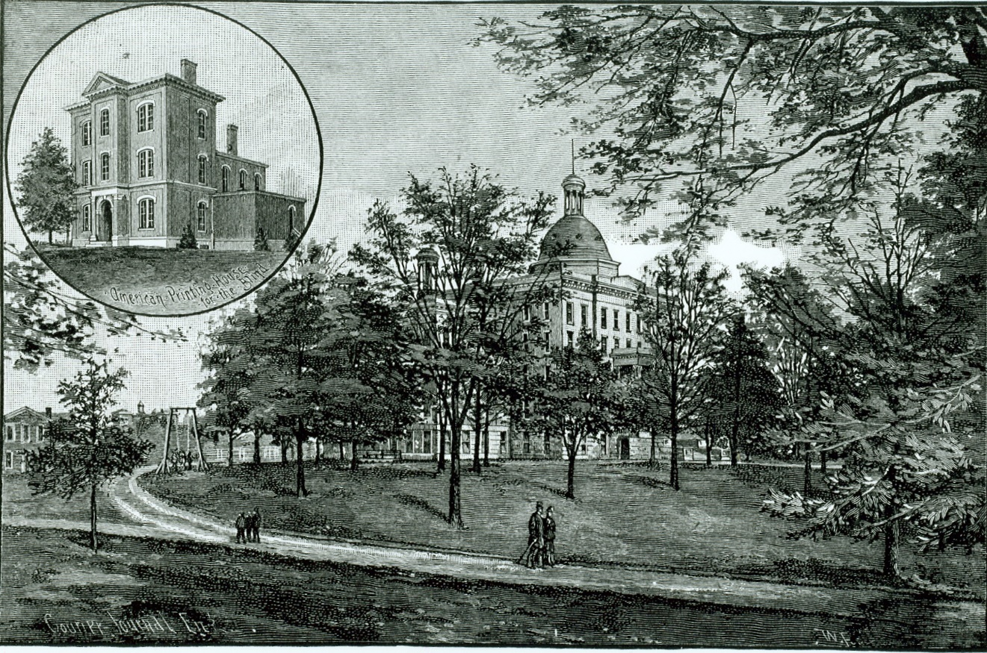

The Kentucky School for the Blind and American Printing House for the Blind (inset), circa 1890.
Image Courtesy of the Callahan Museum/American Printing House for the Blind.

By Michael Alderson, 2006

With Help From Past and Present Members of the Clifton Community Council
Updated July, 2018

19
Introduction
Clifton residents love their neighborhood. For those of us who live, work, and relax here, Clifton is a friendly neighborhood that embraces diversity and doesn’t put on airs. It is what it is— a solid middle-class Victorian neighborhood that’s enjoying a cultural and architectural renaissance. It’s an old-fashioned mix of homes and businesses, where walking to the corner store and waving to the neighbors still matter.
When you look back into Clifton’s history, it’s easy to see why the best qualities of the neighborhood have flourished. For most of its settled history, the Clifton neighborhood has been a community that embraces flexibility, evolution, and transition. It’s a study in Louisville’s transition from an agricultural river town to a thriving industrial metropolis. It’s a neighborhood that bridges the working-class “shotgun” homes of Butchertown with the classic turn-of-the-century Queen Anne and bungalows of Crescent Hill. Clifton preserves this spirit of transition in a way that few other areas in Louisville can— through a uniquely preserved history, diverse architecture, and a melting pot of local culture. Clifton remains one of the most vibrant neighborhoods in Louisville, with nearly 200 years to its credit.
Today, Clifton encompasses over 400 acres and is fortunate to be listed on the National Register of Historic Places. The neighborhood is also a Preservation District under Louisville Metro Code of Ordinances. In fact, this neighborhood history is partially adapted from the National Register of Historic Places-Nomination Forms (1983, 1992) and Historic Preservation District Designation Report (2003).
When you walk through Clifton, you can see how the ambience that attracted early residents to this Victorian community is still evident. With its unusual topography and its refreshing blend of people and properties, it remains a haven for artists, professionals, the visually impaired, and families of all types. To all these resident “Cliftonites” (and everyone else)— enjoy this history of our neighborhood!

The Early Years:
Wilderness, Farmland, and the Bowles Estate
Long before Louisville was settled, the rise of land now home to Clifton was a wilderness of natural foliage bisected by a buffalo trace, a natural path beaten down by the seasonal migration of native buffalo. These traces made convenient trails for the Native Americans (Shawnees from the north and Cherokees from the south) who hunted in the region.
The area’s first brush with colonial settlement was its inclusion in a large land grant issued to various soldiers for their service in the French and Indian War of 1773. Yet even as urban Louisville began to take form in the late 1780s and 1790s, the Clifton area remained undisturbed by agricultural development.
Not surprisingly, its natural landscape was not overlooked for long. Beginning in 1817, the centuries of wild growth began being surveyed with an eye for development. The man principally responsible for settling the area, not to mention giving the neighborhood its name, was Colonel Joshua Bethel Bowles. Bowles was born in Virginia and moved to Louisville in 1816, where he soon sought property in the heights that overlooked Louisville’s eastern edge as a retreat from the bustle of urban Louisville. He began clearing portions of the land in 1817, a
20
process that would continue in phases until 1842, and built a small house on the property sometime around 1820.
At the time of Bowles’ 1817 purchase, the land north of his property (now in Butchertown) was already home to several gristmills and the estate of Colonel Frederick Geiger, who had built a sizeable house, “Linden Hill,” just off Beargrass Creek at present-day Frankfort Avenue. Only a few years before, Colonel Geiger had overseen the construction of the limestone bridge across Beargrass Creek. The bridge heralded future development by allowing access up the hill to Bowles’ property.
When it was finally completed, Bowles’ estate was the first and only “gentleman farm” located in the area (i.e., a farm for use by an estate rather than profit from the sale of produce). In 1842 the small Bowles homestead was overshadowed by the completion of an adjoining mansion—a magnificent 26-room Italianate showplace, finished for Bowles, his wife, Grace, and their three young children. Bowles named the house “Clifton” for the natural cliffs that overlooked the Brownsboro turnpike from the wide, level fields of his property. Nettie Oliver, a genealogist with The Filson Historical Society, describes the house and its history:
The house… at 2143 Sycamore Street in the Clifton neighborhood of Louisville… was built in the early 1800’s by Joshua Bowles . . . (who) was born in 1795 in Virginia and came to Louisville in 1816. By 1842, Bowles had removed himself from the city and purchased the tract of land between Frankfort Avenue and Brownsboro Road. Joshua Bowles was President of the 1st Bank of Louisville serving from 1840 until his death in 1869. On the 1859 Bergmann map of Jefferson County, Bowles is listed on the large tract of land, which is now Clifton neighborhood. When Bowles died he left in his will the house and property to his daughter Margaretta. In 1883, the house and eighteen acres were sold to the Frantz family. After George W. Frantz bought the property, he began to enlarge the house. He raised the ceilings to twelve feet and added a third floor with a ballroom and more bedrooms.
Frantz kept his home just as it had been for many years. Gas fixtures lighted many of the rooms. The 26-room house contained 19 fireplaces, two of which were made from white marble. A bathroom included a wooden copper-lined tub. There were four pairs of ten feet tall paneled walnut doors adorned with brass ornamental hinges and eighty pairs of paneled walnut shutters and three gold leaf and walnut window cornices.
(After) Frantz died in 1959 . . . a public auction was held. Antique dealers turned out in droves to purchase marble statues, bisque figures, marble top tables, mirrors and hand carved beds. Mr. George W. Frantz, while on trips to Italy, supposedly purchased many of these treasured contents . . . After the auction, the property was sold to Mr. Gilbert Westerfield for $75,000 and in 1962, the old home was demolished to make way for a nursing home at 2141 Sycamore Ave.…
Upon its completion, the estate quickly became the area’s defining landmark. Probably thanks to railroad and mail employees, the name of the estate was adopted as a moniker for the whole area, and the neighborhood remains Clifton to this day.
While the Bowles Estate is believed to have been the only gentleman farm sited in what is now the Clifton neighborhood, there are records of at least three other farming families who had
homes in Clifton before 1860: the Rastetters, the Westermans, and the Raymonds. Only one of these original homes survives— the Thomas Rastetter House, which is now located off Payne

21
Street between Payne and Frankfort Avenue. The house sits on a portion of the original fifteen-acre tract of land Rastetter bought south of the Louisville and Shelbyville Turnpike in 1843. The house, which remained in the family until 1923, was built facing Frankfort Avenue around 1844. Forty years later, the main door to the Rastetter house was re-oriented away from Frankfort Avenue to make Payne Street its primary entrance, as it remains to this day.

Roads and Rails
While the wooded acreage of the Bowles Estate was being cleared for farmland, early industry began sweeping outward from Louisville. In the 1830s and 1840s, two transportation-related developments had a major impact on Clifton. The first was the construction of a toll road in the 1830s, the Louisville and Shelbyville (or Lexington) Turnpike—now known as Frankfort Avenue. The toll road replaced and roughly followed the original buffalo trace on its eastward rise from the river valley. Though pioneers had used the old trace since the 1780s, the turnpike straightened and widened its original course to accommodate wagons, buggies, and mule carts bound for local markets.
The construction of this turnpike led to the construction of a number of structures in the next few decades, including a tollhouse, grocery, inn, and tavern. The brick tollhouse at 2311 Frankfort Avenue was a simple federal-style building constructed close to the road, directly beside a tollgate that could be raised and lowered as desired. The tollgate keeper, who lived in the house with his family, was responsible for collecting tolls and maintaining their five-mile stretch of road. The turnpike system was discontinued in 1901, but the tollhouse continued to be used for the public good. In 1908, for example, the building was designated a police substation and jail.
The second major development was the construction of a railway line linking downtown Louisville to the state capital. Begun in the 1840s, this railway, originally known as the Louisville and Frankfort Railroad, later became part of the Louisville & Nashville system. It exists today as the CSX line that bisects Clifton.
Both the toll road and the 1849 completion of the railway heralded rapid development in the area. With traffic constantly stopping at the tollgate, it was not long until commercial buildings were built up around it. One of the biggest was Widman’s Saloon and Grocery (now “The Irish Rover” at 2319 Frankfort Avenue), built in 1858. Along with Spect’s Saloon (ca. 1887), now “Bourbons Bistro” at 2255 Frankfort Avenue, Widman’s was typical of the Clifton commerce that was built up around the turnpike. Located just one block away from each other, the ex-saloons are both two-story brick structures with storefronts on the ground level and living quarters above. Each was constructed in the Italianate style and sited close to the street. Their façade arrangement, style, setback, and massing are quite typical of commercial structures found throughout Louisville in the 1850s. The Widman’s building and the tollhouse were listed on the National Register of Historic Places in 1990.
Another significant development was the construction of the Kentucky School for the Blind, originally chartered in 1842. After a fire devastated its Louisville facility in 1851, the school board bought rural acreage near the turnpike and in 1855 a new school opened. Picturesquely set amid landscaped grounds, the school quickly became a Clifton landmark. It eventually expanded to include the main campus, a “colored” school, and the American Printing House for the Blind. In 1967, the original school was demolished and replaced by a modern facility that
22
serves students to this day at 1867 Frankfort Avenue. Clifton is proud to be home to such an active community of visually impaired residents, and many community features—such as audio crosswalk signals—have been implemented on their behalf.

The Civil War Years
By 1860, Clifton had become a thriving agricultural corridor. Records from the 1860 census, for example, indicate Thomas Rastetter’s land was valued at $4,600. Rastetter also owned two horses, two dairy cows, 10 bushels of peas and beans, 250 bushels of potatoes, 50 bushels of sweet potatoes, truck and garden produce valued at $600, and 100 pounds of butter. A few pockets of natural woodlands remained, but for the most part, landowners and their tenants toiled amid row crops and pastures, while wagons, buggies, and mule carts passed to and fro on the wide, uneven turnpike.
So passed the last days of antebellum Clifton. With the coming of the Civil War, Louisville became a major shipping center for the Union Army. Packet steamers from the north brought ammunition, rations, and supplies through Louisville on their way southward to Mississippi and Louisiana. Louisville became a natural target for Confederate raids, though the one major attempt to seize the city only made it as far as Perryville. After the Battle of Perryville, orders were given to build a system of eleven forts to guard major approaches to Louisville. Clifton, with its commanding location between the Brownsboro and Shelbyville Turnpikes, was chosen as the site of one of these forts, christened Fort Elstner.
Fort Elstner was constructed between 1864 and 1865. The fort was built of earth and timber, with a ditch encircling it, over which a drawbridge provided access to the fort’s interior and underground magazine. The magazine itself housed 200 rounds of artillery shells, enough ammunition to provide continuous volleys of interlocking cross-fire between Fort Elstner and several sister forts. After the war ended in 1865, Fort Elstner was eventually abandoned with the dubious distinction of never having fired a shot in combat.
Very little remains of this Civil War fort, though outlines of the original earthworks may still exist. A stray cannonball or two has also been known to be uncovered in the area. Next time you’re digging in the backyard… be careful!

Clifton Becomes a Neighborhood
Aside from the Clifton Estate and a few scattered farmhouses, very little planned residential development occurred before the Civil War. However, meat processing, quarrying, and distilling were emerging into nearby industries, setting the stage for future residential development in the area. Several natural features encouraged these industries. First, there was a constant water supply provided by the middle fork of the Beargrass Creek—ideal for distilling spirits and processing meat. Secondly, there was an abundance of limestone in the area that attracted quarry companies, whose employees slowly and painstakingly carved away huge chunks of hillside. Traces of the quarry industry are still visible, particularly near present-day Crescent Springs Condominiums, along the Interstate 64 corridor, and along Brownsboro Road at Kenilworth Avenue. The City Workhouse, destroyed by fire in 1968, was another notable remnant of quarrying activity located in adjacent Irish Hill.

23
With quarrying, distilling, and meat packing industries nearby, land speculators soon divided the local farms into residential lots. These developers geared their sales, and the prices of available homes, to three categories of employees: the working class laborers, the middle-class overseers and clerks, and the upper middle-class owners and managers—which is why, in part, Clifton has preserved such a diversity of dwellings.
Generally speaking, the area to the west and north, nearest to Louisville, was developed first. The first house built along Frankfort Avenue in Clifton was the home and office of Dr. Joseph Maxwell, formerly located at 1755 Frankfort Avenue next to the old Hilltop Theater. The Maxwell House was a prominent brick three-story completed in 1871, though its brick vernacular style would prove to be an exception to the rule. Most of the houses built in early developments (called “additions”) of the 1870s and 1880s were clapboard— modest in scale, intended solely to house the working class. Examples of these homes still exist on the north side of William Street.
By the 1880s, however, city-provided services such as police and fire protection, schools, and the availability of water, sewers, and gas (and in rare instances, limited electricity) provided important amenities that would enhance the quality of life for more affluent homebuyers. The housing stock gradually increased in size and scale, reflecting a range of architectural styles. Folk Victorian was the most prevalent, a combination of Italianate, Queen Anne, and Federal styles made possible through the mass production of wooden trim. The low cost and availability of cornices, brackets, bargeboards, and running trim allowed carpenters to liberally apply them to exteriors, often on homes of a simple side-hallway townhouse plan or single or double-pile shotgun homes.
Despite this residential growth, Clifton retained an agricultural undertone. Even up to 1900, Billy Goat Hill, now situated along the cliffs adjacent to Interstate 64, was home to a public spring and a pasture the Whalen family used to raise over 200 goats. The goats roamed freely on the open meadow around Billy Goat Hill (1900-2100 block of Payne St.), a reminder of Clifton’s original agricultural focus well into the 1950s.
Most Clifton homes of the 1880s and 1890s lay somewhere in between the humble three-room shotgun of the laborer and the magnificent brick and stone mansion that has come to define the late Victorian Era. The latter exists in Clifton, but certainly to a lesser degree than the Highlands and Crescent Hill. Some of the finest architecture in Clifton can still be viewed on Frankfort Avenue near Coral Avenue, and also on Coral Avenue overlooking Bingham Park and Vernon Avenue overlooking Brownsboro Road.
The development boom made Clifton an appealing target for annexation by the city. Indeed, the City of Louisville first attempted to annex Clifton in 1856, a move that resulted in the annexation of the western tip of the Clifton neighborhood, constituting the Bowles Estate and northern sections across the Brownsboro Turnpike. That stirred an ambitious movement among residents to keep Clifton autonomous. In 1876, a group of Clifton neighbors petitioned the State Legislature to grant a charter to the township of Clifton, which was home to 75 people at the time. The petition failed, and Clifton was officially recognized as a neighborhood by the City of Louisville in 1891. Clifton was completely annexed by 1897, and by 1910 most of the residential lots had been developed, though intermittent construction of bungalows continued through the 1950s.

24
Case Study: The Development of Pope Street
Pope Street serves as a good example of the type of development that was taking place in Clifton at the end of the nineteenth century. Pope Street is named for Louisville merchant and banker William Hamilton Pope, who had inherited a farm in the area from his father, William Pope, Sr. The younger Pope decided to parcel the land and sell it as the northern block of Pope Street, thus making it one of the early additions to the neighborhood. It was laid out in the late 1870s, just as other antebellum-era farms were beginning to be parceled off into lots.
The original addition included the north sides of William Street and Pope Street, with Embry Avenue connecting the two and forming the streets into the shape of an “H,” hence “William H. Pope”— his permanent calling card in Clifton. The northern blocks of Pope and William streets were the first to link Frankfort Avenue and Brownsboro Road. They appear on the Jefferson County Atlas in 1880. By 1890, however, the section of Pope that existed then as the 1500 block had been built up with shotgun and “camel-back” homes.
The south side of Pope Street does not exist on the 1884 Jefferson County Atlas, though Prospect Avenue (now Arlington Avenue) and Charlton Avenue had already been laid out. At that time, the southern block of Pope was still the eastern-most section of a large track of land owned by J.T. Franck, one of the original Frankfort Avenue landowners.
In 1890, the Franck property was also subdivided into additions. Theodore Harris, Jacob L. Smyser, and Jacob’s wife, Fannie, bought the entire block of land bordered between “Summit Avenue” (later South Pope Street), the alley between Pope and Smyser (later State) Streets, Prospect Avenue, and “a road running along the L&N railway.” The Pope Street frontage of this block was 564 feet long. Harris and the Smysers bought the land for $4,800 on March 8, 1890.
Smyser was a prominent merchant in the firm of Wallace & Lithgow, a manufacturer of stoves, copper, tin, and sheet-iron. This association led him into land business and construction, a enterprise furthered by the relationship with Lithgow, his father-in-law, who was a former mayor of Louisville, director of the Louisville & Frankfort Railway, and a bank president. Through these connections, Harris and the Smysers joined a partnership with the Kentucky Excelsior Manufacturing Company, a building company under the presidency of John Drescher, who was also a partner in Hite & Drescher Real Estate at 1300 Frankfort Avenue. Drescher was instrumental in the founding of the Benjamin Franklin Elementary School, and his name is prominent on the building’s cornerstone to this day.
Under Drescher and Smyser’s development, the south end of Pope Street was laid down as a modern brick street lined with limestone curbs. With their Eastlake, Queen Anne, and Italianate treatments, the Kentucky Excelsior houses on South Pope tended to be slightly larger and grander than the houses on North Pope. The architectural style of many of these houses was the reversed “L-shape,” a type very popular in the 1890s as a cross between the traditional square home and the irregularly massed Queen Anne. Standard L-shaped plans allowed builders, carpenters, and masons to follow established patterns of form, so they could be familiar with a repeating plan and order materials accurately. They could also be fitted on smaller lots.
These first houses on Pope, the tallest homes on all blocks of the street, had commanding views of the area when they were built, since most of the land was stripped of trees and underbrush when the addition was developed in the 1890s. This may be why the new block was initially
25
called “Summit Avenue.” Middle to upper-middle class families soon moved in—first and second-generation German immigrants, including many who worked in the lime, cement, flour, or distillery business.
The Albert A. Stoll firehouse at Frankfort Avenue and Pope Street, built in the Gothic Revival style, was dedicated about this time to house Hook & Ladder Company No. 3.
Stoll—who was also responsible for the construction of the Franklin School—was a member of the Louisville bar. He was born in 1851 and began practicing law in Louisville in 1872. He was elected to the Kentucky Legislature in 1876, thus becoming (at 25) the youngest member of either house. He was again elected in 1884, then elected to the Board of Alderman in 1885 and again in 1887. He finally ended his civic career as School Board President in 1895.
Stoll was a proponent for “suburbanizing” Clifton with the addition of a firehouse and school. The firehouse was constructed in 1890 with a massive corner bell/watch tower that has been removed. The presence of the firehouse hastened residential development in Clifton, as potential buyers saw it as a sign of safety and settled suburban life. The firehouse quickly became a hub of community life in Clifton. After Louisville’s devastating 1937 flood, for example, the firehouse opened as one of several vaccination points throughout the city. Neighbors stretched up and down the “high ground” of Frankfort Avenue and Pope Street, fearful of disease in a city suddenly lacking clean water and working sanitation systems.

A Clifton Home, Circa 1895
The Clifton home of the 1890s was a study in late Victorian middle-class living. It was a modest clapboard residence of between three and eight rooms, fitted with masonry chimneys and a tin roof and situated on a narrow lot—often no more than 25 feet wide—over a small brick cellar.
On the exterior, the small front yard was fenced in to keep out pigs and wild goats, especially on and around Payne Street. The wooden clapboard exterior, sometimes “German grooved” for additional detail, was ornamented slightly differently than its neighbors. Finish work— Italianate cornices over the upper windows, a profusion of gingerbread brackets along the porches, leaded art glass in floral patterns over the front windows—differentiated it from the houses on either side of it. This was the formal front that the family put forward, concealing a rear yard that was often full of drying laundry and airing rugs. An outbuilding stood at the rear of the lot to accommodate a horse and sometimes buggy, as well as tools, coal, kindling, and chickens—even goats. An underground cistern gathered drinking water.
Like all late Victorian homes, the interior of the Clifton home was divided into specific spaces—formal (front hall, parlor, dining room, and staircase hall), utilitarian (kitchen, pantry, rear porch, and shed), and private (bedchambers and bathroom, if one existed). Some of these rooms were fitted with gas-fed wall fixtures for lighting, since electricity was considered a gamble, subject to sporadic outages while emitting harsher light than gas lamps (though hissing gas fixtures tended to produce greasy, messy discolorations on walls and ceilings). A few of the rooms also had fireplaces fitted with coal grates, which had to be fed constantly in the winter. The coal itself had to be lugged in bins from where the delivery carts left it in the alley shed—a dirty, smudgy process.
The Clifton home’s formal rooms were often open to one another and close to a front porch so the family could move inside and outside easily during summer living. Transoms opened over all
26
the doors, allowing breezes to easily circulate throughout the house. Portiere rods were run in the doorways between the formal rooms and hallways, so heavy curtains could be hung for privacy and to retain heat from the fireplaces in the wintertime.
Because it was not custom built, the Clifton home was fitted in a rather conservative style, suggesting the Eastlake craze, which came into vogue in 1876. All of the interior walls were finished in horsehair plaster over wood lathe, with wallpaper laid directly onto the wet plaster of the walls and ceilings. Vines, trellises, and roses abounded on the wallpaper in popular shades of buff, dark brown, dark green, India red, maroon, or gold.
Some of the upper middle-class households in Clifton employed outside help for cooking and laundry. Few retained live-in servants. Often, children and relatives helped with the chores or tended to modest vegetable gardens. The side and rear doors of the house were used the most, leaving the front door for formal guests. The side door, often fitted with a manually rung doorbell, was an informal entrance for friends and a service entrance for the tradespeople who visited, selling their wares.
The family who lived in this house sweated through the humid summers on their porches, shivered in the winter in rooms that smelled of burning coal and gas, rode the mule trains and trolleys to and from Louisville, listened to the shrill whistle of trains as they rumbled past, and watched as Frankfort Avenue grew from a rural toll road to a busy suburban street.

The Frankfort Avenue Business Corridor
The construction of the turnpike made Frankfort Avenue a natural business corridor. In its early years, commercial and residential development co-existed on Frankfort Avenue. Shotgun houses and larger frame residences set back off the road were common. In addition, two-story buildings with commercial storefronts on the first floor and storage areas or a residence on the second were built to attract two types of customers: Clifton residents living nearby and urban Louisville residents passing through on the toll road.
Beginning around 1910, some of the homes that fronted Frankfort Avenue began being converted to commercial use. A few of these suffered little or no change to the building’s main façade, while most others were altered at the ground floor level with the addition of new storefronts or wholesale sheathing of all or part of the primary façade with a new “commercial skin.” These changes continue to occur up to the present day.
In Then and Now: The Frankfort Avenue-Clifton Experience from 1933 to 1994, Paul Kinsella recalls commercial activity in the business corridor before and after World War II:
From 1933 until 1961 I lived on the south side of Frankfort Avenue just a few steps east of Clifton Avenue. For many years, from 1933 to 1947, my mother ran a restaurant directly across the street from where we lived.
The building in which Genny's Diner is now located was a long time ago when we first moved into the neighborhood the Grocers Ice and Cold Storage Company . . . I remember when I was a kid buying a small hunk of ice (fifty pounds) and— with a shiny metal ice tong— carry or drag it along the sidewalk some distance down the street to our restaurant. There I would chop it into small pieces and spread them on top or between the bottles of soft drinks or beer in the cooler behind the bar.

27
On the corner of Frankfort and Rastetter was another business that was there when I was a kid and for many years later. It was the Messmer Hardware Store. It, too, was sort of an “institution,” for it was very important to the needs of those who lived in the Clifton neighborhood. They seemed to have everything in the hardware line needed for survival in that slower-paced less, complicated world. Now in this same building is the Clifton’s Pizza Company . . .
I remember a horse-drawn vegetable wagon that used to stop in front of our restaurant every day during the warm weather. And my mother used to go outside to haggle with the vendor for produce. It was used as part of her delicious home cooked plate lunches.
(The original toll house) became the Clifton Police Station from 1908 until 1932. My friend, Clarence Wettstein, whom I mentioned previously, told me that he remembers the police from this station patrolling the neighborhood on bicycles.
Later . . . Freddie Mueller and his wife Polly ran the Old Toll House Tavern in that same building. There was an outside beer 'garden behind the building with a large concrete slab used as a dance floor. It was surrounded by wooden tables—the tops painted white—and chairs. Overhead strings of colorful lights added to the glamour. And in one corner an over-sized jukebox played all of the songs of the era. It was really a fun place to go and live it up.
Clifton boasted many large and impressive commercial facilities: The Kentucky School for the Blind (built in 1853 and 1899); The Printing House for the Blind (built in 1858 and 1883, with later additions); The Vernon Avenue School (which existed between 1891 and 1919); Benjamin Franklin Elementary School on State Street (built in 1892, then rehabilitated with additions in 1966); Hook and Ladder Company No. 3/The Albert A. Stoll Firehouse (built in 1890, then remodeled in 1909); The Sacred Heart Convalescent Home (built in 1892); the German Evangelical Church/Clifton Unitarian Church (built circa 1900); the Third Lutheran Church (built in 1931); St. Frances of Rome Catholic Church (built in 1887 and rebuilt in 1910); and St. Frances of Rome Catholic School (built in 1930). All are or were located within the boundaries of the Clifton neighborhood—a testament to the positive educational, spiritual, and social atmosphere Clifton residents continue to enjoy.

Transitional Years: 1950 - 1980
Development slowed after the close of the Second World War. With the automobile firmly established and highways opening new corridors of development, families began moving deeper into the county, to suburbs made suddenly more accessible. Clifton families who had been original homeowners joined the exodus, leaving their aging homes to be split up into apartments and boarding houses. Some houses were demolished in favor of apartment building and industrial complexes; others were drastically re-faced with brick and aluminum siding. The trolley stopped running and the old trolley yard where the cars turned around on their way back to the city was closed. Pool halls and bars sprung up where corner grocery stores and pharmacies once stood. Interstate 64 was constructed, obliterating a large portion of Clifton’s southwestern border, including an African-American community that had been settled in the valley around Beargrass Creek and the quarry. Clifton suddenly found itself in the midst of urban blight.

28
For several decades, the neighborhood remained in a state of functional obsolescence. Yet some of the original families held out, maintaining their homes with pride. Visual artists, sculptors, and musicians—including famous Louisville artist Barney Bright—moved into Clifton, attracted in part by the large studio space available for low rent. In time, the art community flourished in Clifton. To this day, the neighborhood is home to a thriving community of writers, poets, actors and actresses, musicians, sculptors, metalworkers, and visual artists of all types… the anchors of Clifton’s cultural scene. Clifton continues to blossom as a community of colorful and wide-ranging creativity.
Renaissance: A Historic Preservation District
Fortunately, it was not long before Clifton began to be recognized for its historic charm and importance. After the 1974 tornado devastated parts of historic Louisville, a group of concerned residents and businesses got together to form the Clifton Community Council, a volunteer organization dedicated to sustaining the historic integrity and diversity of the neighborhood. A formal step in Clifton’s preservation came in 1983 with the listing of portions of the neighborhood on the National Register of Historic Places. This listing was based on the area’s historical significance related to architecture, education, and industry, and ushered in the first of several succeeding waves of rejuvenation of the neighborhood.
Restoration of the Frankfort Avenue business corridor, including the planting of flowering trees and the renovation of storefronts, began in earnest in the early 1990s. In 1994 the Clifton Historic District’s National Register-boundaries were significantly expanded based on additional historical significance in the areas of community planning and development. In 2003, thanks to the hard work and determination of the Council, the entire Clifton neighborhood was approved as a Preservation District under Louisville Metro Code of Ordinances.
Today, Clifton continues to undergo a renaissance of residential and commercial renovation. Recent successes include the restoration and creation of parks, environmental preserves, biking trails, walking paths, and features designed specifically to accommodate the visually impaired. Houses are being restored to their original glory, and new homes and condominiums are welcoming first-time homeowners to the community.
With the support of the Clifton Community Council and local civic and business leaders, Clifton looks forward to many more years of preservation, beautification, and celebration. We are truly a community preserving the past and planning the future!

29
Sources
In addition to original research conducted at the Jefferson County Courthouse and Louisville Free Public Library, the following sources have been helpful in creating this brief history of the Clifton neighborhood:
Clifton Community Council (2000). 2000-2010 Clifton Neighborhood Plan.
Cook, Clara (2006). Personal interview. Conducted interview in February 2006.
Cunningham, Robert (Unknown). Places in Time: Clifton. Retrieved April 26, 2006, from http://www.courier-journal.com/reweb/community/placetime/eastend-clifton.html.
Frankfort Avenue Business Association (2005). The Guide to Historic Frankfort Avenue.
Hedgepeth, Marty, Director of Research, Louisville Landmarks Commission (January 1983). National Register of Historic Places Inventory-Nomination Form.
Johnson, L.R. (1974). The Falls City Engineers: A History of the Louisville District Corps of Engineers, United States Army. Army Corps of Engineers: Louisville.
Kinsella, Paul (1994). Then and Now: The Frankfort Avenue-Clifton Experience from 1933 to 1994. Retrieved August 2, 2006, from http://www.neighborhoodlink.com-/louisville/cliftoncc/genpage/929395698.html.
O’Leary, Mike (2006). Personal interviews. Conducted interviews on multiple dates in Spring 2006.
Oliver, Nettie. Christmas Card Collection. Retrieved August 1, 2006 from http://www.filsonhistorical.org/news_v5n4_christmas.html.
Perrin, Battle, & Kniffin (1888). Kentucky: A History of the State. Retrieved April 27, 2006, from http://www.rootsweb.com/~kygenweb/kybiog/jefferson/stoll.aa.txt.
Weeter, Joanne, Research Coordinator, Louisville Landmarks Commission (August 1, 1992) National Register of Historic Places Registration Form.
Weeter, Joanne, Historic Preservation Officer, Louisville Metro Planning and Design Services (August 27, 2003). Clifton Historic Preservation District Designation Report. Retrieved July 20, 2018 from, https://louisvilleky.gov/sites/default/files/planning_design/landmarks_and_historic_pres/clifton_designationreport.pdf.
Weeter, Joanne (2006). Personal interview. Conducted interview in May 2006.

30
Clifton Street Names
Excerpted from the history of St. Frances of Rome Catholic Church published in 1962, the 75th anniversary of the founding of the parish, researched and written by Charles W. Beckman, Sr.

How often as we walk down one of our streets in Clifton, do we ask "How did this street get to be called this?" Of the many streets in St Frances of Rome Parish, we give here the names and origins.

Letterle Avenue - formerly known as Brownsboro Road. It was named for John M. Letterle, a pork packer and the first president of the Butcher's Union No. 1.

Mellwood Avenue - named for the Mellwood Distillery.

Frankfort Avenue - named for Frankfort, Kentucky, the State Capital. It was formerly called

Shelbyville Turnpike, with its first toll gate at Frankfort and Jane Streets.

William Street - Pope Street - H Street (now Embry) - named for William H. Pope, who laid out this section of the city. These three streets form the letter 'H' between Frankfort and Letterle Avenue.

Payne Street - named for W. B.Payne, a member of the Louisville Charter Committee for the year 1828.

Stoll Avenue - named for Albert A. Stoll, president of the school board in 1895.

Spring Street - named for a never failing spring in a bed of watercress situated near Spring Street, east of the L & N R.R. tracks.

Vernon Avenue - named for W. S. Vernon.

Keats Avenue - named for George Keats, a brother of John Keats, the Poet. Payne, Vernon and Keats were members of the Louisville Charter Committee of 1828. Vernon Avenue, however, was formerly known as Bowles Lane.

Ewing Avenue - Jane Avenue - named for Ewing and Jane Speed, children of George K. Speed, whose ancestral home at what is now Ewing and Frankfort Avenue was called "Chatsworth".

Haldeman Avenue - named for W. N. Haldeman, publisher of the Courier-Journal.

Clifton Avenue - formerly called Cavewood, because it led to a cave at the fringe of the woods to the rear of the Taylor-Rudd Home, Payne Street.

Franck and Rastetter - named for property owners where these families resided.

31
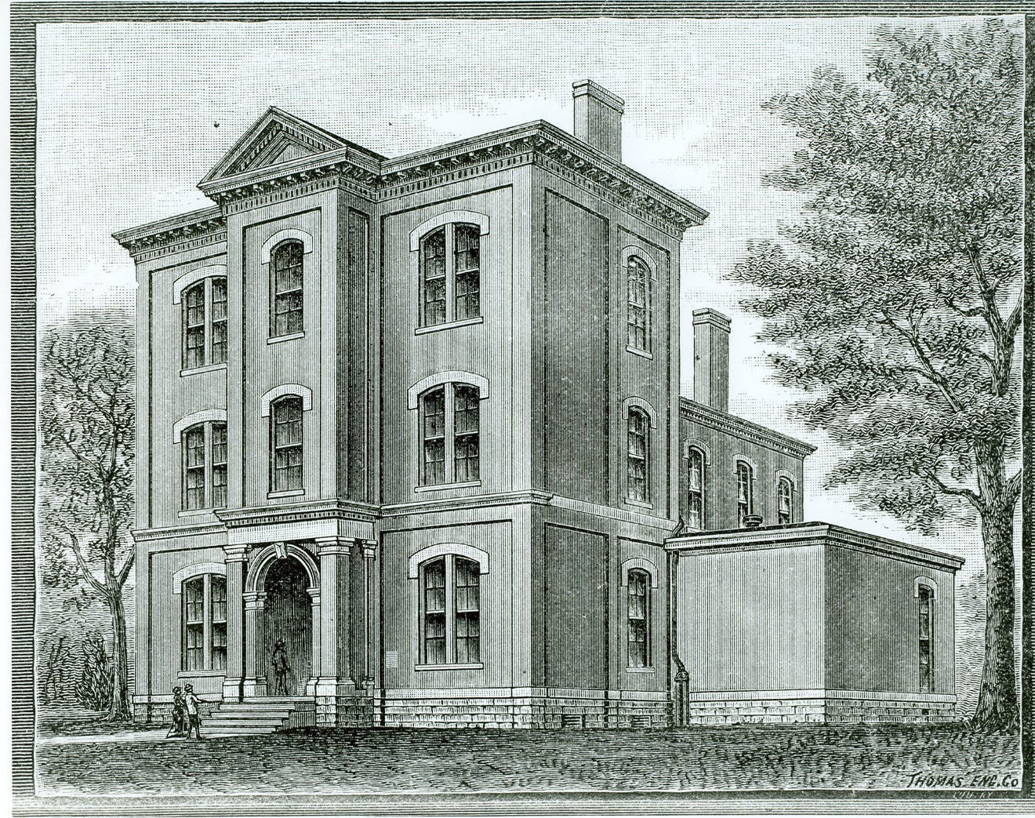

The American Printing House for the Blind, ca. 1883.

Image Courtesy of the Callahan Museum/American Printing House for the Blind.

© 2006
Updated July 2018

The Clifton Community Council

Please reprint with permission only.

